One Page Report
Name of the Course |  | Make – A – Product : Phase I & II |  |  |  |  | Regulation | R2023
MAP – Title |  | Portable Roadside Plant Cutting Machine
Team Members ( Regular(R) / Optional(O)):
S.No | Register No. | Name of the Student(s) |  |  | R/O |  | Year/Dept./Section
1 | 611223114030 | GURU PRASANNA V |  |  | R |  | III/MECH/A
2 | 611223114042 | KARTHI VS |  |  | R |  | III/MECH/A
3 | 611223114043 | KARTHICK SS |  |  | R |  | III/MECH/A
4 | 611223106013 | BRAJEETH G |  |  | O |  | III/ECE/A
5 | 611223104170 | THIRAGNATH J |  |  | O |  | III/CSE/A
Problem Statement |  | - Manual vegetation cutting methods are labor-intensive, time-consuming, and unsafe for workers near highways. Existing cutting methods lack portability, making it difficult to perform cutting operations directly at highway or on-site locations.  - Existing machines are bulky, expensive, and lack portability for small-scale roadside maintenance.
Target Customer |  | - Highway Construction Companies.  - Companies involved in road and highway development need efficient plate cutting for barriers, joints, and structures.  - Road Maintenance & Government Departments.
Solution Methodology & Product |  | - Portable & Efficient Cutting System.  - Develop a compact, easily movable machine that enables on-site highway plate cutting, reducing time delay and eliminating the need for transportation.  - Integrate safety guards, stable clamping, and simple controls to ensure safe operation and reduce risks for workers during cutting processes.
Uniqueness of Product  (Max. 5 Points) |  | - On-Site Portable Cutting Capability  - Unlike conventional machines, this system is designed to be used directly on highways, eliminating the need to transport heavy plates to workshops.  - Integrated Precision + Safety System
Snap Shot |  | 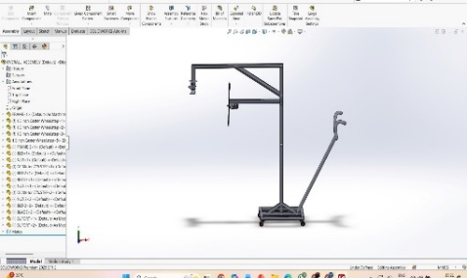  Product photo |  | Team photo  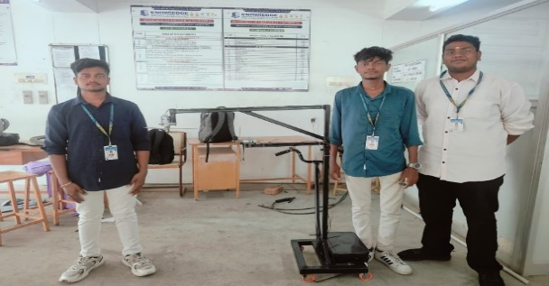
SDG No(s). Alignment |  |  | Technical Club Aligned |  |  | SUSTAINABLE ENGINEERING CLUB
MAP Guide  Name & Designation |  |  | MAP Coordinator Name & Designation
Signature |  |  | Signature

